**1. (a) What is the difference between band reject filter and notch filter? (b) What is roll off of a filter? Should it be faster or slower? why?**

**Answer (a):**

In [signal processing](https://en.wikipedia.org/wiki/Signal_processing), a band-rejection filter is a [filter](https://en.wikipedia.org/wiki/Filter_(signal_processing)) that passes most [frequencies](https://en.wikipedia.org/wiki/Frequency) unaltered, but [attenuates](https://en.wikipedia.org/wiki/Attenuate) those in a specific range to very low levels. It is the opposite of a [band-pass filter](https://en.wikipedia.org/wiki/Band-pass_filter).

A notch filter is a kind of band-rejection filter with a narrow [stopband](https://en.wikipedia.org/wiki/Stopband) and high [Q factor](https://en.wikipedia.org/wiki/Q_factor).

**Answer (b):**

Roll-off is the steepness of a transfer function with frequency, particularly in electrical network analysis, and most especially in connection with filter circuits in the transition between a passband and a stopband.

It is the slope of the filter’s response in the transition region between the pass-band and stop-band. Rolloff is given in dB/octave (a doubling of frequency) or dB/decade (ten times the frequency). If the response changes rapidly with frequency, that rolloff is termed steep.

Roll-off is the magnitude of the amplitude shift with a filter frequency. The faster the roll-off, or the higher the attenuation rate, the more selective the filter example the better it is able to distinguish between two signals are spaced closely, one desired and the other not. So my viewpoint, It should be faster. Because as it would be faster it will be be sharp to fall. Therefore, it will be easier to cut off frequencies.

**2. What is the difference between AM and ASK? Which types of signal are used to be modulated by them? What is SSB? Why is it okay to send sideband instead of the whole modulated signal?**

**Answer:**

**ASK:** Amplitude shift keying(ASK) is a type of amplitude modulation that represents digital data. In this we transmit a carrier wave(RF) of high frequency when the binary digit is 1 and no signal when the binary signal is 0. But for practical purposes a very less amplitude signal is still transmitted for the distinguish for the 1 and 0 transmitted. Here the modulating signal is a digital signal that is varied in accordance with the amplitude of a carrier signal.

**AM:** In amplitude modulation, the modulating signal is a analog signal which is varied in accordance with amplitude of a carrier signal.

In this the message signal is multiplied with the carrier(RF) of high frequency. By doing this the amplitude of the carrier is changed according to the message signal voltage which is low frequency. So the carrier is being modulated in amplitude by the message signal.

**SSB:** single-sideband modulation (SSB) is a type of modulation used to transmit information, such as an audio signal, by radio waves.

Why is it okay to send sideband instead of the whole modulated signal?

SSB takes advantage of the fact that the entire original signal is encoded in each of these "sidebands". It is not necessary to transmit both sidebands plus the carrier, as a suitable receiver can extract the entire original signal from either the upper or lower sideband.

**3. What is FM? What is the purpose of Bessel function regarding FM? What is the benefit of Carson's rule against general equation for bandwidth of FM?**

**Answer:**

Frequency modulation (**FM**) is the encoding of information in a carrier wave by varying the instantaneous frequency of the wave.

In FM, the carrier amplitude remains constant and the carrier frequency is changed by the modulating signal. As the amplitude of the information signal varies, the carrier frequency shifts proportionately. As the modulating signal amplitude increases, the carrier frequency increases.

**What is the purpose of Bessel function regarding FM?**

The total bandwidth of an FM signal can be determined by the modulation index. From the modulation index, the number and amplitudes of significant sidebands is determined by solving basic equation of an FM signal.

If we’d like to understand this signal in terms of cosines without any frequency modulation. It turns out the result is a set of cosines weighted by **Bessel functions** of β.

**What is the benefit of Carson's rule against general equation for bandwidth of FM?**

The bandwidth of an FM signal is not as straightforward to calculate as that of an AM signal.

A very useful rule of thumb used by many engineers to determine the bandwidth of an FM signal for radio broadcast and radio communications systems is known as Carson's Rule. This rule states that 98% of the signal power is contained within a bandwidth equal to the deviation frequency, plus the modulation frequency doubled.

The rule is also very useful when determining the bandwidth of many two ways radio communications systems. These use narrow band FM, and it is particularly important that the sidebands do not cause interference to adjacent channels that may be occupied by other users.

**4. Give a single advantage of digital communication over analog communication and explain it in your own word.**

As the signals are digitized, there are many advantages of digital communication over analog communication.

From my point of view, one of the major advantages of digital communication is the effect of distortion and noise is much less in digital signals. Because they use signal regeneration rather than signal amplification. Noise produced in electronic circuit is additive, therefore S/N ratio deteriorates each time an analog signal is amplified.

**5. Explain the operation of PCM. (Draw a picture of PCM in paper and upload the figure in the next answer). What are the advantages and disadvantages of taking too many number of bits to represent each sample?**

Pulse-code modulation (PCM) is a method used to digitally represent sampled analog signals. In a PCM stream, the amplitude of the analog signal is sampled regularly at uniform intervals, and each sample is quantized to the nearest value within a range of digital steps.

It is a standardized method that is used in the telephone network to change an analog signal to a digital one for transmission through the digital telecommunications network.

A signal is pulse code modulated to convert its analog information into a binary sequence, i.e., 1s and 0s. The output of a PCM will resemble a binary sequence.

Instead of a pulse train, PCM produces a series of numbers or digits, and hence this process is called as digital. Each one of these digits, though in binary code, represent the approximate amplitude of the signal sample at that instant.

In Pulse Code Modulation, the message signal is represented by a sequence of coded pulses. This message signal is achieved by representing the signal in discrete form in both time and amplitude.

The transmitter section of a Pulse Code Modulator circuit consists of Sampling, Quantizing and Encoding, which are performed in the analog-to-digital converter section. The low pass filter prior to sampling prevents aliasing of the message signal.

The basic operations in the receiver section are regeneration of impaired signals, decoding, and reconstruction of the quantized pulse train.

**Answer to question no: 6**

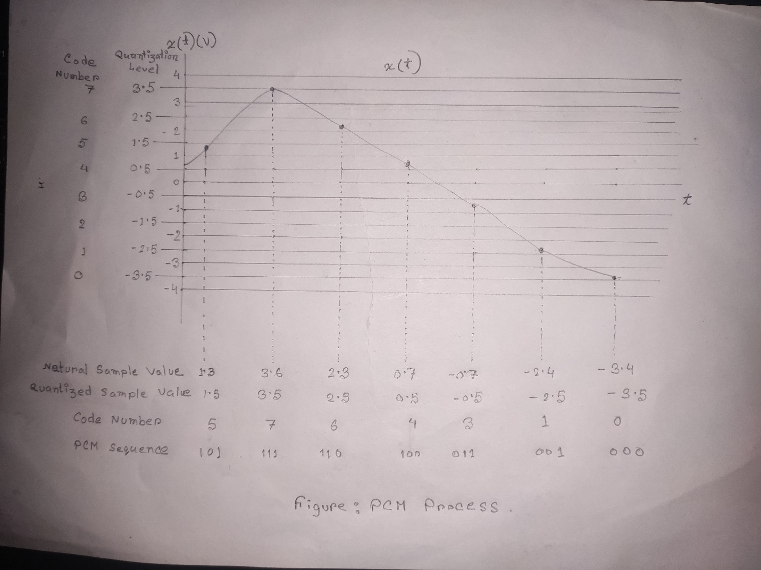

**7. What is the difference between AF and RF amplifier?**

RF amplifiers are radio frequency amplifiers. They increase the amplitude of radio frequency waves. 20kHz to 300GHz. These are found in satellites, cell phone towers and in dish antennas.

AF amplifiers are audio frequency amplifiers. They increase the amplitude of waves that we can listen. 20Hz to 20kHz. These are widely used in speakers, microphones, earphones, etc (almost any electronic device that you can hear)

**Why both of them are used in transmitter or receiver?**

A transmitter or receiver is an electronic device used in communications to produce radio waves in order to transmit or receive data with the aid of an antenna.

amplifiers are used to increase the  [power](https://whatis.techtarget.com/definition/power) of a [signal](https://searchnetworking.techtarget.com/definition/signal) in [wireless](https://searchmobilecomputing.techtarget.com/definition/wireless) communications and broadcasting, and in [audio](https://whatis.techtarget.com/definition/audio) equipment of all kinds.

A radio frequency power amplifier (RF power amplifier) is a type of electronic amplifier that converts a low-power radio-frequency signal into a higher power signal. Typically, RF power amplifiers drive the antenna of a transmitter.

Audio frequency amplifiers (AF amplifier), used to amplify signals in the human hearing range around 20Hz-20kHz, while some Hi-Fi AF (audio amplifiers) spread this range up to around 100kHz, whereas other audio amplifiers may control the limit of high frequency to 15kHz or less.

So, we can say. to get the information properly in within the human limitation AF and RF amplifiers are used

**8. What is the difference between TDM and FDM?**

**TDM** **(Time Division Multiplexing)** and **FDM (Frequency Division Multiplexing)** are the two techniques of multiplexing. The common difference between TDM and FDM is that TDM share the timescale for the different signals; Whereas FDM shares the frequency scale for the different signals.

Secondly, TDM is used for both digital signal and analog signal while FDM is used for only analog signals

Thirdly, interference for TDM is Low & for FDM interference is high

Finally , circuitry for TDM is simpler & FDM is comparatively complex